Integration of Parametric Geometry into IFC-Bridge

Yang Ji1, Jakob Beetz2, Nicholas Nisbet3, Peter Bonsma4, Casimir Katz5, André Borrmann1  
1Computational Modelling and Simulation Group, Technische Universität München, Germany  
2Design Systems Group, Eindhoven University of Technology, The Netherlands  
3AEC3 Ltd., United Kingdom  
4RDF Technical Geometry/Semantic Web, Bulgaria  
5SOFiSTiK AG, Germany  
{ji, andre.borrmann}@tum.de; j.beetz@tue.nl

**Abstract:** IFC (Industry Foundation Classes) is the commonly accepted data exchange standard for Building Information Models (BIM). However, the geometric representation in IFC is restricted to explicit, extrusion and CSG (Constructive Solid Geometry) approaches. Accordingly, the exchange of parametric geometry between parametric design applications used in the AEC (Architecture, Engineering and Construction) industry is not possible. This paper proposes an object-oriented data structure extending IFC-Bridge which supports parametric geometry representations, using geometric constraints and mathematical expressions to define dependencies between geometric entities and their dimensions. The extended data schema is implemented and evaluated with a real-world application scenario from the civil engineering domain.

# Introduction

Parametric modeling opens new ways for representing geometry of buildings and infrastructure constructions in a flexible, easily adaptable manner. Parametric geometry refers to the use of geometric constraints and the mathematical formulation of interdependencies between them (Shah and Mäntylä, 1995). Parametric modeling approaches have been explored in different areas in the AEC industry. Modeling a building using a parametric 3D computer-aided design (CAD) system offers numerous benefits in terms of the ability to rapidly generate design alternatives and elimination of errors that result from design changes (Sacks et al. 2004). In architectural design, the combination of parametric design with computational tools allows for a better support of the early conceptual phase of the design process (Turrin et al. 2011; Hubers, 2010). In civil engineering, the parametric description of bridges provides structural engineers the possibility to optimize the structural design (Katz, 2008; Ji et al. 2010). Furthermore, parametric 3D infrastructure models are used to improve the integration between the geotechnical design and analysis processes (Obergrießer et al. 2011).

Building Information Modeling (BIM) is widely applied in the AEC industry covering architectural design, structural analysis, construction and facility management (Eastman et al. 2008). The Industry Foundation Classes (IFC) schema (ISO 2005a) is recognized as the data exchange standard for interoperability of BIM-based applications. Although IFC is a rich product modeling schema which provides multiple ways to define objects, relations and attributes, the underlying geometric representation is limited to explicit, simple extrusion and CSG (Constructive Solid Geometry) approaches. On the one hand side, the exchange of explicit geometry can be easily realized, which is advantageous for the implementation of the IFC standard. On the other side, it constitutes a threshold to the advances of using IFC. The rigid geometric data in the IFC models cannot be configured in consistence with design intensions after model exchange, not even after re-import in the creating systems. Therefore, further use of the geometric data is limited to visualization and communication purposes. This is not a sufficient way of data exchange in case of design, analysis and engineering processes, where advanced geometric dependencies between objects are required. The “best practice” is to reconstruct geometric dependencies in the target system which is time-consuming and error-prone (Sacks et al. 2004; Katz, 2008; Venugopal et al. 2011).

The key to solving these issues is to integrate the possibility to describe parametric geometry into IFC. As a first step, the research documented in this paper aims at the integration of parametric geometry into IFC-Bridge, which is an extension to the IFC model for exchanging bridge models. In the second step, further integration of parametric geometry into IFC for exchanging parametric building models is discussed.

# Parametric Modeling of Bridges

Bridges are geometrically complex civil engineering objects. Numerous dependencies between the geometric entities and elaborated 3D curved surfaces increase the design complexity significantly. Especially in case of design changes, the geometric dependencies can be hardly managed using a conventional 2D design approach. In contrast, parametric 3D modeling provides a fast and accurate way to define bridges. The parametric description of bridges reduces the overhead of updating the geometric model. Furthermore, design intensions contained in the parametric model can be used for structural analysis (Katz, 2008; Ji et al. 2011).

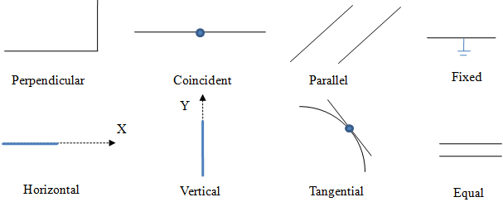

Figure 1: Common geometric constraints

The principle of parametric bridge modeling is illustrated in Figures 1 and 2. In the beginning, a parametric sketch is created with primitive geometric objects, e.g. lines and arcs. Their topological relationships are determined by a set of geometric constraints. For example, the upper part of the bridge profile defines the geometric form of the carriage way through the bridge. Normally, this part is constant in the course of the bridge superstructure. A bridge designer can use the geometric constraint “Fixed” to set this part of profile constant. Similarly, the length of two or more geometric entities can be set equal with “EqualLength”. Even topological dependencies of primitive entities are definable with “Coincident” for instance.

There are eight common geometric constraints required in parametric bridge modeling (Figure 1). In addition, specific dimensions (e.g. vertical and horizontal distance, angle between lines) can be defined as dimensional constraint with a specific parameter. In the bridge profile depicted in Figure 2, the length (“cs2_w”) and the height (“cs2_h”) of the cross section are such dimensional constraints. A dimensional parameter can take two different types of values: an explicit numeric value or a descriptive mathematical expression consisting of arithmetic operators and operands. The operands refer to other defined dimensional parameters by name. Mathematical dependencies between dimensional parameters can be formulated in this way. If the value of a parameter changes, all related expressions are re-evaluated, this leads to an automatic updating of the entire geometry model.

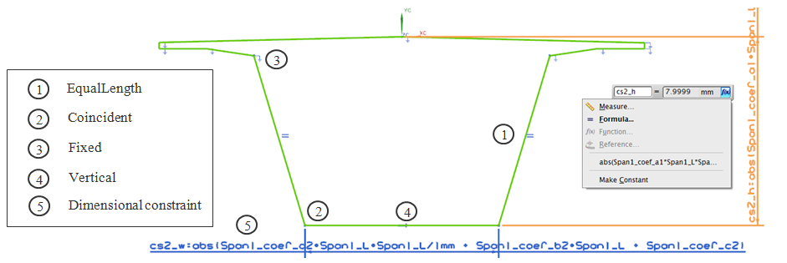

Figure 2: Parametric sketch of bridge superstructure

Geometric constraints and dimensional constraints are advanced modeling techniques for creating parametric models. The advantage is that the geometric model is driven directly by design intensions. It offers numerous benefits, such as the ability to rapidly generate design alternatives and analyze the bridge structure. Figure 3 shows a fully parameterized bridge superstructure. The geometric form of the bridge profile (e.g height and width of the cross section) is parameterized with respect to the superstructure’s haunch curve. The solid geometry is generated through extrusion of the bridge profile along the reference curve. The parabolic form of the bridge haunch is described by a parametric formula. Structural engineers are able to derive cross section geometry at any position of the bridge axis which is a flexible and accurate way of assessing structural data.

# Integration Parametric Geometry into IFC-Bridge

IFC-Bridge is an extension of the IFC data model for exchanging bridge models based on IFC (Yakubi et al. 2006; Arthaud and Lebegue, 2007). It contains a rich set of building element types required for describing bridges. The means of geometric representation are adapted directly from IFC. The geometric form of the bridge superstructure element is represented by prismatic segments (“IfcBridgePrismatic­Element”). These segments are divided by means of structural parts according to bridge spans. Figure 4 shows an example composed of three segments separated by two abutments and two piers. The geometry of a superstructure segment is defined by means of an arbitrary number of profiles located along the reference axis (Figure 4). This is basically a suitable approach. However, in the current draft of IFC-Bridge the individual profiles are defined independently from each other, using explicit dimensions. This results in an inflexible geometric structure, since in the case that the designer modifies the haunch curve, all profiles have to be adapted individually.

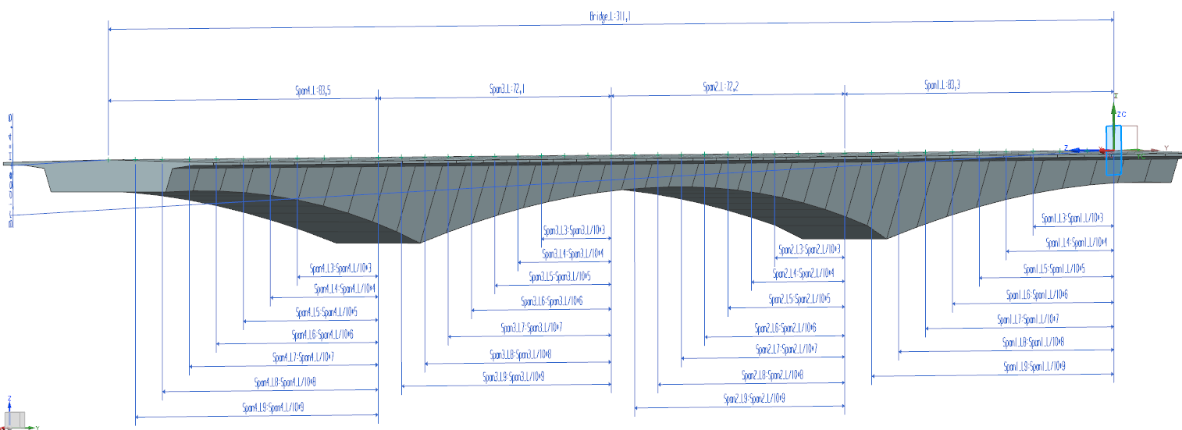

Figure 3: Parametric geometric model of bridge superstructure

In order to approximate the geometric form, in particular the parabolic haunch geometry, a large number of cross sections are described explicitly and located along the bridge axis (Figure 4). This approximation to a curved superstructure shape complicates the structural analysis, in particular the calculation of centrifugal forces or the effects of post stressing tendons (Katz, 2008).

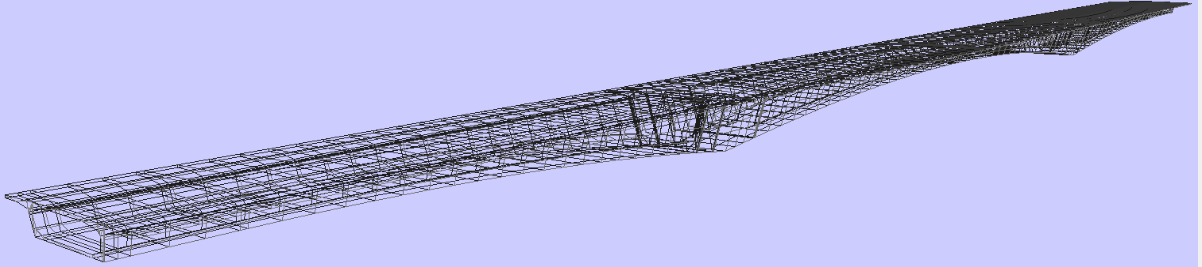

Figure 4: Approximation of bridge superstructure using explicit geometry

Although the bridge geometry can be transferred from one application to another using IFC-Bridge, design intensions (i.e. geometric dependencies etc.) are lost. These have to be manually reproduced in the target system. An integration of parametric geometry into IFC-Bridge addresses this problem.

The proposed data structure extends the bridge profile definition in IFC-Bridge. It introduces a new entity named “IfcParametricProfileDef”. This entity contains elements for describing parametric sketches with geometric and dimensional constraints as described in Section 2. The data structure is illustrated in an EXPRESS-G diagram provided in Figure 5.

A parametric sketch of type “IfcParametricProfileDef” consists of a set of primitive geometric elements such as points, lines and arcs.

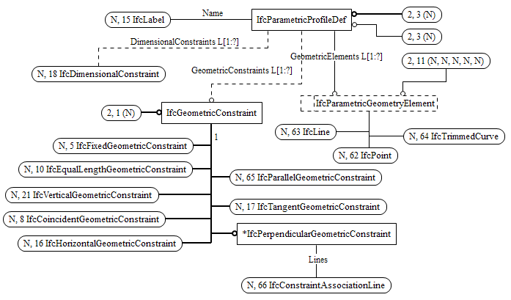

Figure 5: EXPRESS-G Diagram of extended IFC-Bridge classes “IfcParametricProfileDef” and “IfcGeometricConstraint”

Their geometric relationships are definable using eight geometric constraints derived from the class “IfcGeometricConstraint”. For example, the geometric constraint “*perpendicular*” (“IfcPerpendicularGeometricConstraint”) can be applied to two line objects of a sketch element. The number and the type of geometric entities in association with a specific geometric constraint are defined explicitly.

The mathematical dependencies between dimensional parameters play an essential role in parametric modeling. This part of the schema extension is depicted separately in Figure 6. The class “IfcDimensionalConstraint” is a general class of the five types of dimensional constraints that cover different possibilities to define a dimensional parameter. For example, the entity “IfcAngularDimensionalConstraint” defines the angle between two lines. Similar to the definition of “IfcGeometricConstraints”, geometric entities associated with a dimensional constraint are explicitly defined.

Each dimensional constraint is associated with a dimensional parameter defined in “IfcParametricFormula”. In order to formulate mathematical dependencies between dimensional parameters, the composite design pattern from software engineering (Gamm et al. 1995) is adapted here (Figure 7). The intent of a composite is to recursively organize part-whole relationships in a hierarchical tree-like structure. For example, to describe the expression “Height: = Width + Length / 2 + 5”, an object of type “IfcParametricFormula” is created as root element. It is decomposed into three different elements defined in the enumeration type “IfcParametricValueSet”: numeric values (“IfcParametricConstant”) such as the number “5”, references of other dimensional parameter (“IfcParametricBinding”) in this case the “Width” or other formula elements (“IfcParametricFormula”), as for example “Length / 2”. Additionally, a formula element is associated with a set of commonly used arithmetic operators (e.g. “PLUS”, “MINUS”, “DIVISION”, “TIMES”) enumerated in the type “IfcParametricOperatorEnum”. The “USERDEFINED” operator allows expressions such as “Width + Length / 2 + 5” to be included without disaggregation, but the expression must then be parsed by the receiving application. The range of predefined operators can be extended depending on the demand in engineering practice (Nisbet, 2011).

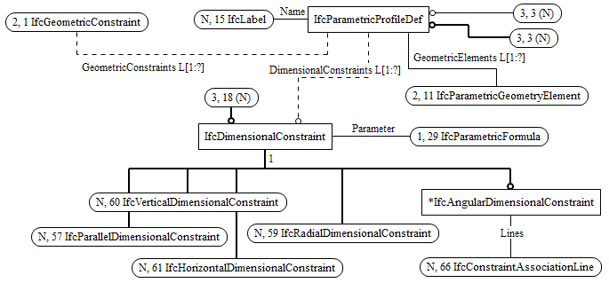

Figure 6: EXPRESS-G Diagram of extended IFC-Bridge class “IfcDimensionalConstraint”

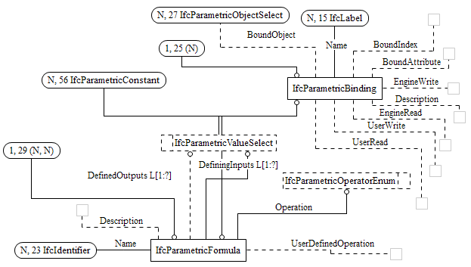

Figure 7: EXPRESS-G Diagram of extended IFC-Bridge class “IfcParametricFormula” and “IfcParametricBinding”

The entity “IfcParametricBinding” offers two different options for defining dimensional parameters. The first option is the creation of a stand-alone parameter with a specific name. The second option is to bind a stand-alone parameter to an existing object attribute. For example, the dimensional parameter “Height_Door” can be linked with the attribute “OverallHeight” of an IFC door object. This is necessary, since the direct use of existing object attributes in parametric formula is not allowed. The parametric description is added as a knowledge representation upon the rigid geometric representation in the IFC model. The edition and changes of the geometric representation and the existing object attributes are always driven by the parametric description.

# Application scenario

The extended IFC-Bridge schema is evaluated in a real-world application scenario. The lifecycle of bridges consists of design, structural analysis, construction and maintenance. Design and analysis are heavily interrelated processes in the early stage. In the presented application scenario, a bridge designer uses a parametric 3D modeling system for bridge modeling. The design parameters are specified in cooperation with structural engineers. The parametric description includes the definition of the bridge axis, the haunch form and the cross section of the superstructure. The height and the width of the cross-section are defined in dimensional dependency to the bridge axis and the structural line. Consequently, the geometric form of the superstructure is accurately determined using a parametric description. The design model is exported into the extended IFC-Bridge data model. In the next step, a structural analysis system imports the parametric geometry of the bridge model and reconstructs automatically the geometric form as well as the parametric description. This type of modeling for bridges provides structural engineers the possibility to have consistent data with the bridge designer by sharing design intensions and using them for optimizing the bridge structure.

The proposed parametric IFC-Bridge schema allows to exchange parametric models between design and structural analysis systems. The parametric description of bridge structures can be shared by both domain-specific systems. The data interoperability is improved significantly.

# Conclusion and Outlook

Parametric modeling is a promising novel design approach in the AEC industry. However, the current IFC schema does not support parametric geometry which forms a barrier to advances of using IFC as a standard exchange format. This paper presents a data structure for parametric description of bridge structures. The parametric data schema is integrated into IFC-Bridge. The application scenario shows that the extended IFC-Bridge solves the data interoperability problem between bridge design and structural analysis systems.

The further work focuses on the integration of parametric geometry into IFC for exchanging parametric building models. Parametric IFC models provide designers and engineers the opportunity to edit the parametric geometry according to their requirements in a flexible way. A parametric description ensures the consistency of the model after the application of changes. IFC can be extended to define the configuration rules and interface, allowing others to implement his directly or indirectly.

# References

Arthaud, G. and Lebegue, E., (2007). IFC-Bridge V2 Data Model, edition R7.

Eastman, C., Teicholz, P., Sacks, R., Liston, K., (2008). BIM Handbook: A Guide to Building Information Modeling for Owners, Managers, Designers, Engineers and Contractors, John Wiley & Sons, Inc.

ISO (International Organization for Standardization), (2005a). ISO/PAS 16739: Industry Foundation Classes, Release 2x, Platform Specification.

Gamma, E., Helm, R., Johnson, R., Vlissides, J., (1995). Design Patterns: Elements of Reusable Object-Oriented Software. Addison-Wesley. ISBN 0-201-63361-2.

Hubers, J. C., (2010). IFC based BIM or Parametric Design? In Proc. of the International Conference on Computing in Civil and Building Engineering (ICCCBE), Nottingham, UK.

Ji, Y., Borrmann, A., Obergrießer, M., (2011). Towards the Exchange of Parametric Bridge Models using a Neutral Data Format. In Proc. of the ASCE International Workshop on Computing in Civil Engineering, Miami, US.

Ji, Y., Obergrießer, M., Borrmann, A., (2010). Development of IFC-Bridge-based Applications in Parametric Design Systems (in German). In Proc. of the 22th Conference Forum Bauinformatik, Berlin, Germany.

Katz, C., (2008). Parametric Description of Bridge Structures. In Proc. of the IABSE Conference on Information and Communication Technology for Bridges, Buildings and Construction Practice, Helsinki, Finland.

Obergrießer, M., Euringer, T., Borrmann, A., Rank, E., (2011). Integration of Geotechnical Design and Analysis Processes using a Parametric and 3D-Model based Approach. In Proc. of the ASCE International Workshop on Computing in Civil Engineering, Miami, US.

Nisbet, N., (2011). Proposed Parametric Extension for IFC2x3. (Private correspondence).

Sacks, R., Eastman, C. M., Lee, G., (2004). Parametric 3D Modeling in Building Construction with Examples from Precast Concrete. Automation in Construction, 13(3).

Shah, J. J. and Mäntylä, M., (1995). Parametric and Feature-based CAD/CAM - Concepts, Techniques, Applications, Wiley Press Inc.

Turrin, M., Von Buelow, P., Kilian A., Stouffs, R., (2011). Parametric Modeling and Genetic Algorithms for Adaptable Architecture. In Proc. of EG-ICE Workshop – European Group for Intelligent Computing in Engineering, Twente, NL.

Venugopal, M., Eastman, C., Sacks, R., Teizer, J., (2011). Improving the Robustness of Model Exchanges using Product Modeling Concepts for IFC Schema. In Proc. of the ASCE International Workshop on Computing in Civil Engineering, Miami, US.

Yabuki, N., Lebeque, E., Gual, J., Shitani, T., Li, Z. T., (2006). International Collaboration for Developing the Bridge Product Model IFC-Bridge. In Proc. of the International Conference on Computing and Decision Making in Civil and Building Engineering.